COMP1682.1 Project Proposal
Develop a Fashion Store E-Commerce System using Java(....)
[Pham Vo Nhut Truong]
BSc (Hons) Computing
[001584160]
- Overview
In the modern digital transformation era, the online fashion industry is experiencing rapid expansion. Modern consumers increasingly demand seamless digital channels to explore trends, filter clothing items, manage shopping carts, and purchase apparel securely online.
However, conventional e-commerce platforms often struggle to deliver an optimal shopping experience tailored to fashion retail. Standard websites frequently lack intuitive interfaces and flexible product architectures to gracefully display multi attribute garments including diverse sizes, colorways, and material options, often leading to confusing user navigation, inaccurate stock displays at checkout, and degraded customer satisfaction.
To address these challenges, this project focuses on designing and developing a feature rich Fashion Store E-Commerce Website using the Java programming language and the Spring Boot framework. The platform provides a complete end-to-end online shopping ecosystem, featuring interactive product catalogs, product search by keyword and filtering by gender, size, color, price range, and collection, seamless cart management, secure user accounts, and integrated checkout workflows alongside backend store administration.
This solution delivers significant operational and commercial benefits. For consumers, it provides a highly responsive, visually appealing, and secure web platform that simplifies clothing discovery and online purchasing. For fashion retailers, it delivers a scalable digital storefront that streamlines product variant displays and maintains accurate online stock availability. Ultimately, the project enhances digital brand presence while elevating overall customer engagement in the competitive online fashion market.
Keywords: Fashion E-Commerce Website, Java, Spring Boot, Online Shopping Platform, Web Development, Product.
- Aim
The aim of this project is to develop a fashion store e-commerce system that allows apparel retailers to manage their online storefront and business operations in a centralized and efficient way. The system will integrate multiple functions into a single platform to support both online shoppers and store administrators. In terms of functionality, the system will include product management, allowing administrators to display and update complex clothing items with multi-attribute variants such as sizes, colors, and materials. It will also provide an interactive catalog and shopping cart system, where customers can filter products, check real-time item availability in the warehouse, and manage their purchases online. In addition, the system will support warehouse stock and vendor management, enabling administrators to manage items stored in the warehouse and coordinate supplier details. Another important feature is user authentication, which allows users to register, log in, and securely access their personal profiles and order history. The system will also include a secure checkout function, where customers can finalize orders, choose shipping options, and make payments online. To support business operations, the system will provide order management and sales reporting features, helping administrators track revenue, order fulfillment status, and overall performance. By integrating these core functions, the system helps reduce manual administration, minimize warehouse management errors, and improve overall operational efficiency. At the same time, it enhances the customer experience by making clothing discovery intuitive and convenient, while also supporting fashion brands in expanding their digital market presence and increasing sales revenue.
- Related works / Literature review

3.1. Related works

3.1.1. MySQL
MySQL is an open source Relational Database Management System developed and supported by Oracle Corporation, widely recognized for its high performance, security, and scalability. It employs Structured Query Language to manage, query, and manipulate data organized into structured relational tables. In modern web applications, such as a gym management system, MySQL serves as the centralized storage engine responsible for maintaining critical operational datasets, including member records, trainer profiles, class schedules, and transaction histories. By leveraging indexing, relational integrity constraints, and ACID compliant transaction processing, MySQL eliminates data redundancy, accelerates query retrieval, and ensures secure, consistent multi user access for seamless system operations. (Oracle, 2026).

3.1.2. Front-end Development Technologies
Front-end Development is the development or creation of a user interface using some markup languages and other tools. It is the development of the user side where only user interaction will be counted. It consists of the interface where buttons, texts, alignments, etc are involved and used by the user. Built with HTML, CSS, and JavaScript, this project integrates dynamic browser interactions, modern UI design, and robust page structuring. (GeeksforGeeks, 2025).

3.1.3. Development Environment
A development environment in software and web development is a workspace for developers to make changes without breaking anything in a live environment.
The development environment is often seen as a developer's “everything-goes” workspace. When working with a development environment it is part of a tiered structure of environments, where changes are deployed through different environments before reaching a live website. A typical environment structure includes a local, a development, a staging, and a live environment, but it can include more or fewer environments depending on the needs and processes of those developing the website. (Umbraco, 2025).

3.1.4. Version Control Tools
Version control, also known as source control, is the practice of tracking and managing changes to software code. Version control systems are software tools that help software teams manage changes to source code over time. As development environments have accelerated, version control systems help software teams work faster and smarter. They are especially useful for DevOps teams since they help them to reduce development time and increase successful deployments. (Atlassian, 2025).

3.1.5. Back-end Development Technologies
The backend (or server side) manages a web application's overall functionality by receiving HTTP requests from the frontend, processing them, and returning appropriate responses. During this process, it actively interacts with database servers, microservices, and third-party APIs to retrieve data and execute specific tasks. To efficiently handle thousands of simultaneous requests, the backend leverages various communication protocols alongside concurrency and parallelism techniques, such as distributing traffic across multiple servers, caching, and data duplication. (Amazon Web Services, 2026).

3.2 Literature review
E-commerce has become an important part of modern retail because it allows customers to search, compare, and purchase products through online platforms. In the fashion industry, an e-commerce website needs to provide more than basic product information because fashion products often have different sizes, colors, materials, and stock quantities. Therefore, a fashion e-commerce system should support product searching, filtering, product variants, shopping carts, checkout, order management, and inventory control. These functions help customers find suitable products more easily and help retailers manage their products and stock more accurately.
Web-based systems are suitable for e-commerce because users can access the system directly through a web browser. For this project, Java is selected as the main programming language because it supports object-oriented programming and is widely used for web and enterprise applications (Oracle, 2025). Spring Boot is used as the main development framework because it simplifies Java web development and supports database access, security, and application structure (Spring, 2026). A relational database such as MySQL can also be used to store information about users, products, categories, product variants, shopping carts, orders, and inventory (Oracle, 2026). These technologies provide a suitable technical foundation for developing a structured online fashion store.
The project will use the Waterfall Model as the software development methodology. Waterfall follows a sequential process that normally includes requirements analysis, system design, implementation, testing, deployment, and maintenance (Ruparelia, 2010). This model is suitable for the project because the main requirements are identified before development begins. Major changes after the requirements phase should be limited because changes can affect system design, development time, testing, and project cost. The project is planned to be completed within six months following these phases.
Zalando is used as a reference because it is a large multi-brand fashion e-commerce platform operating across different European markets. It provides customers with a wide range of fashion products, personalised recommendations, size guidance, and services for retail partners (Zalando, 2026). In comparison, the BEO Fashion E-Commerce Website will have a smaller and more focused scope. Rather than supporting many independent brands and sellers, it will manage the BEO Fashion product catalogue and its store operations. The system will include product search and filtering, product variants, shopping carts, online payment options, order history, and inventory management.
Unlike Zalando, the system will not operate as a marketplace for multiple independent brands or sellers. Instead, it will support BEO Fashion staff in managing products, stock, customers, orders, and store operations. The system will also include features such as store location, staff management, stock adjustment, and stock transfer between stores. Although its scope will be smaller than Zalando, it will focus on the functions needed for BEO Fashion to operate an online fashion store and manage its internal retail activities.
- Objectives
  - System Requirements and Design
    - Outcome describing this objective in more detail
A complete requirements specification and system design for the Fashion Store E-Commerce Website that defines the functional requirements, non-functional requirements, system architecture, database structure, user interfaces, and system models before the implementation phase.
    - Analyze the functional and non-functional requirements of the Fashion Store E-Commerce Website. [0.5 month]
    - Design the system architecture, database structure, user interfaces, and system diagrams based on the identified requirements. [0.5 month]
  - Customer Shopping System
    - Outcome describing this objective in more detail
A functional and user-friendly online shopping system that enables customers to create accounts, explore fashion products, select appropriate product variants, manage shopping carts, and complete online purchases.
    - Develop customer registration, login, and profile management functions. Enable customers to browse products, view product details, search by keyword, and filter products by gender, size, color, price range, and collection. [1.0 month]
    - Implement product variant selection, shopping cart, checkout, payment, order placement, and order history functions. [1.0 month]
  - Product and Store Management System
    - Outcome describing this objective in more detail
A centralized administration system that enables administrators to effectively manage fashion products, product variants, inventory, customers, and orders while maintaining accurate product and stock information.
    - Develop product, category, brand, size, color, material, product variant, image, and inventory management functions. [1.0 month]
    - Implement administrative management, order management, and role-based access control using Spring Security. [0.5 month]
  - System Quality and Deployment
    - Outcome describing this objective in more detail
A tested, secure, stable, and deployable Fashion Store E-Commerce Website that satisfies the specified requirements and provides reliable functionality for both customers and administrators.
    - Test the completed system through unit testing, integration testing, functional testing, and system testing, and correct identified defects. [1.0 month]
    - Deploy the completed Fashion Store E-Commerce Website to the target environment and verify its main functions. [0.5 month]
  - Project Framework or Any Methodology used
Waterfall and Scrum are two possible approaches to developing the Fashion Store E-Commerce Website. Waterfall follows a sequential process, where requirements and system design are completed before implementation begins (Ruparelia, 2010). In contrast, Scrum develops the system through short Sprints. At the end of each Sprint, the work is reviewed and the next priorities can be adjusted. Scrum is useful when requirements are unclear or likely to change during development. It also normally involves a Scrum Team, including a Product Owner, Scrum Master, and Developers (Schwaber and Sutherland, 2020).
The Waterfall Model will be used for the Fashion Store E-Commerce Website. The main functions can be identified before development, including customer registration and login, product browsing and filtering, size and colour selection, shopping cart management, online payment options, order management, and inventory management. Since these requirements are already defined, Waterfall will provide a clear structure for organising the work and completing the project within the planned six-month period. Scrum would allow frequent changes and feedback, but Waterfall is more suitable because the proposed scope is expected to remain stable. Waterfall will also support the preparation of documents such as the requirements specification, database design, system diagrams, and test results for the academic report.
The project will be completed within six months. The work will follow six phases: Requirements Analysis, System Design, Implementation, Testing, Deployment, and Maintenance. The requirements, system architecture, database, and user interfaces will first be defined and designed. The system will then be developed using Java and Spring Boot for the backend and React for the frontend. Testing will include unit, integration, functional, and system testing to check that the system meets the requirements and identify errors. Finally, the website will be deployed, its main functions will be verified, and initial maintenance will be carried out to fix any remaining issues.
- Legal, Social, Ethical and Professional
Introduction:
The project aim of this project is to design and implement a modern, high performance Fashion Store E-Commerce System using Java. By providing dynamic catalog management, real time multi variant inventory tracking, and intuitive online checkout, the system delivers operational efficiency to fashion retailers and a seamless shopping experience to consumers.
In the digital commerce landscape, technical functionality alone is insufficient to guarantee project success. Adhering to legal, social, ethical, and professional (LSEP) standards is paramount to ensure regulatory compliance, protect user data, prevent platform abuse, and build trust among stakeholders. In the context of the United Kingdom, e-commerce applications must strictly align with statutory frameworks and professional codes of conduct to mitigate operational and liability risks.
  - Legal
Legal issues in an e-commerce system involve complying with laws that protect consumers, personal data, and online transactions. Businesses must process customer information lawfully, provide clear and accurate product information, use fair terms and conditions, and respect consumer rights throughout the purchasing process. They are also responsible for ensuring secure payment methods and protecting intellectual property. Compliance with UK legislation helps organisations avoid legal disputes, maintain customer trust, and operate responsibly in the digital marketplace. (Conway, 2025; GOV.UK, 2026).
  - Social
Social issues in e-commerce focus on the impact of online business activities on customers and society. Businesses should promote fairness, transparency, and inclusivity by providing honest product information, accessible websites, and responsive customer service. They should also prevent misleading advertising, fake reviews, and unfair commercial practices that may influence consumer decisions. Demonstrating social responsibility strengthens public confidence, improves customer satisfaction, and encourages long-term relationships between businesses and consumers. (Competition and Markets Authority, 2025).
  - Ethical
Ethical issues in e-commerce concern the responsible and honest use of technology, customer data, and business practices. Organisations should respect customer privacy, collect only the information that is necessary, and be transparent about how data is used. They should avoid deceptive marketing, hidden charges, and manipulative website designs that pressure customers into making unwanted purchases. Following ethical principles helps businesses build trust, enhance their reputation, and create a positive online shopping experience. (Government Digital Service, 2025).
  - Professional
Professional issues in e-commerce relate to the responsibilities of businesses and IT professionals when developing and maintaining online systems. Professionals are expected to demonstrate integrity, accountability, competence, and respect for confidentiality while delivering secure and reliable services. They should follow recognised standards, manage risks effectively, and ensure that systems protect customer information from unauthorised access. Maintaining professional conduct improves service quality, supports legal compliance, and reinforces customer confidence in digital businesses. (Solicitors Regulation Authority, 2026).
- Planning (see appendix A)
The Fashion Store E-Commerce Website project is planned to be completed within six months using the Waterfall Model. The schedule is divided into sequential phases, and each phase must be completed before the next phase begins.
Table 1: Project Development Schedule
Phase | Activities | Start Week | End Week | Duration
Requirements Analysis | Collect and analyze the functional and non-functional requirements of the Fashion Store E-Commerce Website, including user registration, authentication, product browsing, product search and filtering, shopping cart, checkout, order management, inventory management, administration, and security requirements. | Week 1 | Week 2 | 2 weeks
System Design | Design the system architecture, database structure, user interfaces, and system diagrams based on the finalized requirements. The design also defines product variants such as size, color, material, price, and stock quantity. | Week 3 | Week 4 | 2 weeks
Implementation | Develop the system using Java and Spring Boot, including customer accounts, product catalogs, product variants, search and filtering, shopping cart, checkout, payment, order management, inventory management, administrator functions, and role-based security. | Week 5 | Week 18 | 14 weeks
Testing | Conduct unit testing, integration testing, functional testing, and system testing. Identify and fix defects to ensure that all implemented functions meet the approved requirements. | Week 19 | Week 22 | 4 weeks
Deployment | Deploy the completed Fashion Store E-Commerce Website to the target environment and verify the main system functions under actual operating conditions. | Week 23 | Week 23 | 1 week
Maintenance | Perform initial maintenance after deployment, fix minor issues, monitor system stability, and improve reliability where necessary. | Week 24 | Week 24 | 1 week
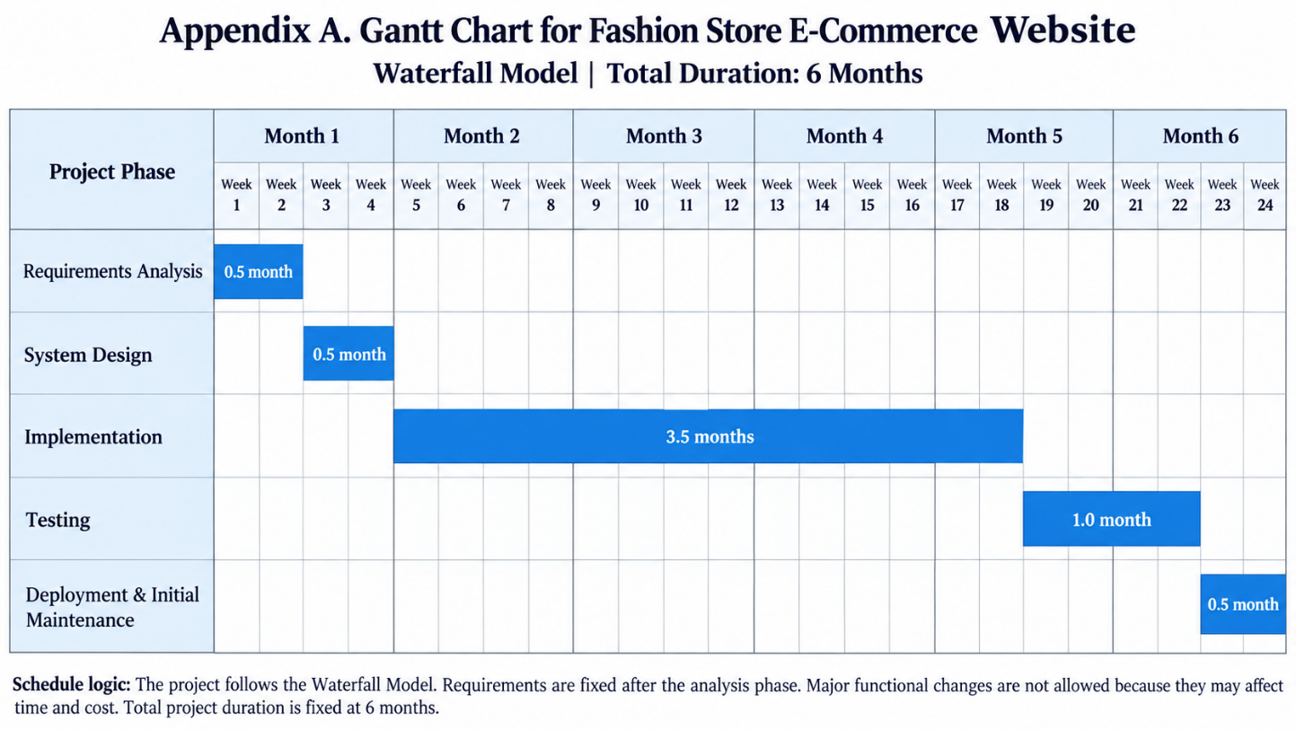
Use-case Diagram
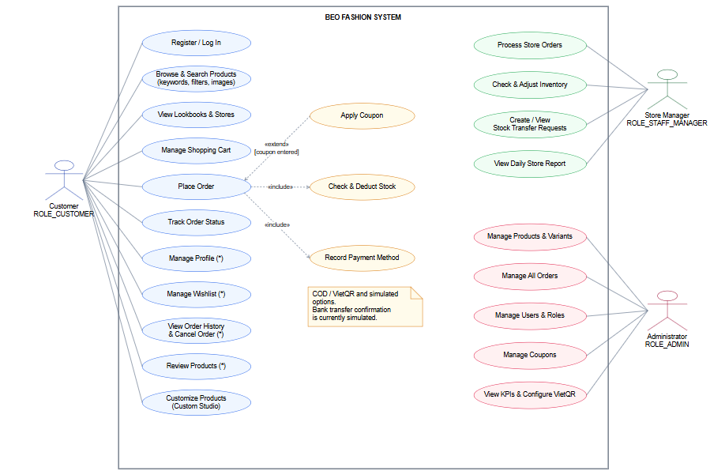

- Initial References

References
Amazon Web Services (2026) 'What's the difference between frontend and backend in application development?'. Available at: https://aws.amazon.com/compare/the-difference-between-frontend-and-backend/ (Accessed: 4 October 2026).
Atlassian (2025) 'What is version control?'. Available at: https://www.atlassian.com/git/tutorials/what-is-version-control (Accessed: 4 October 2026).
Competition and Markets Authority (2025) 'What businesses need to know about unfair commercial practices'. Available at: https://www.gov.uk/government/publications/what-businesses-need-to-know-about-unfair-commercial-practices/what-businesses-need-to-know-about-unfair-commercial-practices (Accessed: 4 October 2026).
Conway, L. (2025) 'Consumer Rights Act 2015'. UK Parliament. Available at: https://commonslibrary.parliament.uk/research-briefings/sn06588/ (Accessed: 4 October 2026).
GeeksforGeeks (2025) 'Front-end development'. Available at: https://www.geeksforgeeks.org/blogs/front-end-development/ (Accessed: 4 October 2026).
Government Digital Service (2025) 'Find data ethics guidance, standards and frameworks'. GOV.UK. Available at: https://www.gov.uk/guidance/find-data-ethics-guidance-standards-and-frameworks (Accessed: 4 October 2026).
GOV.UK (2026) 'Data protection: The UK's data protection legislation'. Available at: https://www.gov.uk/data-protection (Accessed: 4 October 2026).
Oracle (2025) 'Java documentation'. Available at: https://docs.oracle.com/en/java/index.html (Accessed: 4 October 2026).
Oracle (2026) 'MySQL 8.0 Reference Manual'. Available at: https://dev.mysql.com/doc/refman/8.0/en/ (Accessed: 4 October 2026).
Ruparelia, N. B. (2010) 'Software development lifecycle models', ACM SIGSOFT Software Engineering Notes, 35(3), pp. 8-13. Available at: https://doi.org/10.1145/1764810.1764814.
Schwaber, K. and Sutherland, J. (2020) The Scrum Guide: The Definitive Guide to Scrum: The Rules of the Game. Available at: https://scrumguides.org/scrum-guide.html (Accessed: 4 October 2026).
Solicitors Regulation Authority (2026) 'Upholding professional ethics'. Available at: https://guidance.sra.org.uk/home/hot-topics/upholding-professional-ethics/ (Accessed: 4 October 2026).
Spring (2026) 'Spring Boot Reference Documentation'. Available at: https://docs.spring.io/spring-boot/reference/ (Accessed: 4 October 2026).
Umbraco (2025) 'Development environment'. Available at: https://umbraco.com/knowledge-base/development-environment/ (Accessed: 4 October 2026).
Zalando (2026) 'Building the ecosystem for fashion and lifestyle e-commerce'. Available at: https://corporate.zalando.com/en/about-us/holistic-strategy-connected-fashion-world (Accessed: 4 October 2026).

Declaration of AI Use
Please append this page to the end of your assignment when you have used AI during the process of undertaking the assignment to acknowledge the ways in which you have used it.

I have used AI while undertaking my assignment in the following ways:
- To develop research questions on the topic – NO
- To create an outline of the topic – NO
- To explain concepts – YES
- To support my use of language – YES
- To summarise the following articles/resources: NO

